**Static Website Hosting with S3 Bucket**

: First go to the S3 bucket

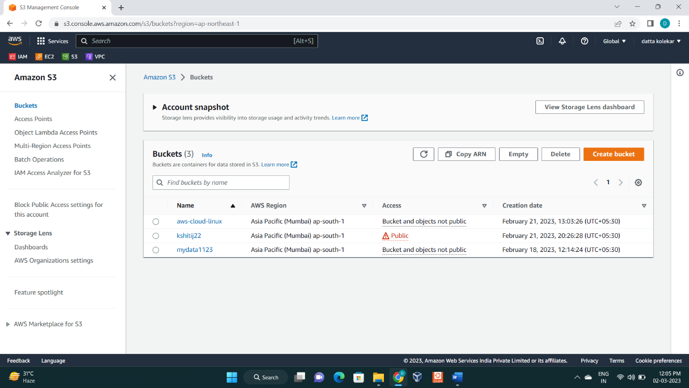

:Lets create static website hosting for existing bucket **“kshitij22”**

:Lets go into **“kshitij22”** bucket

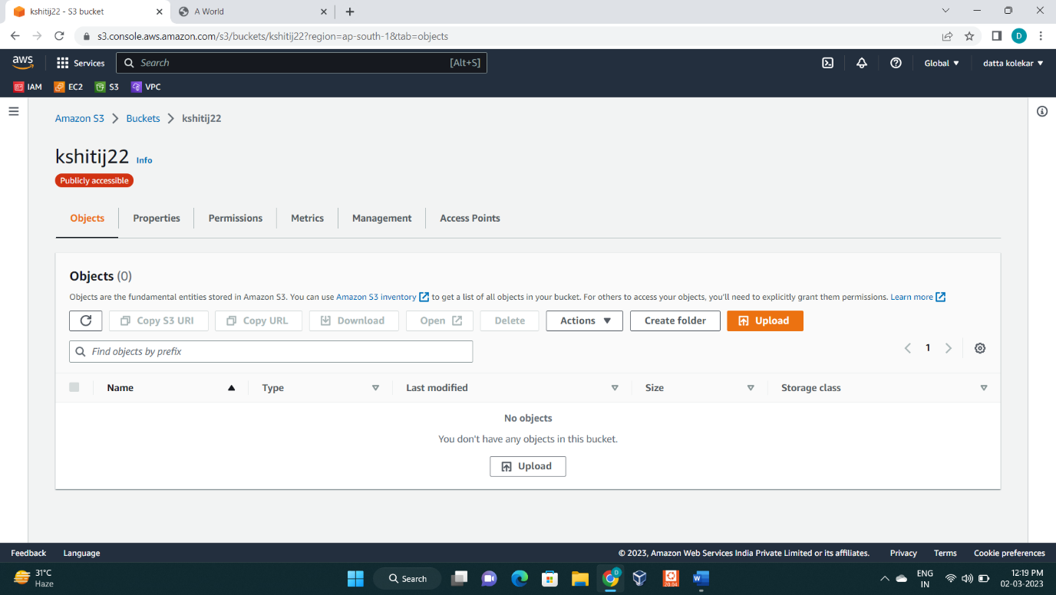

: Click on upload button

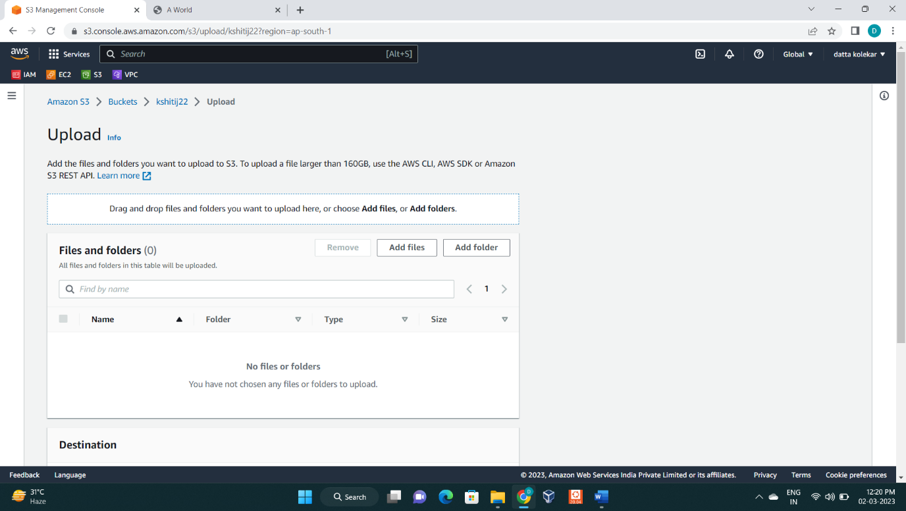

:Upload the files for static website hosting.

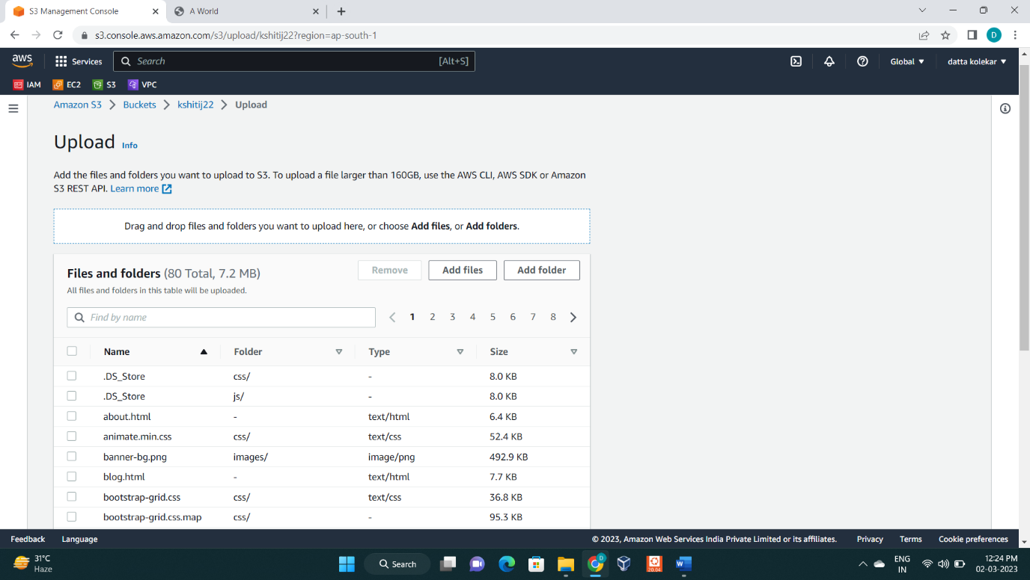

: Click on upload button

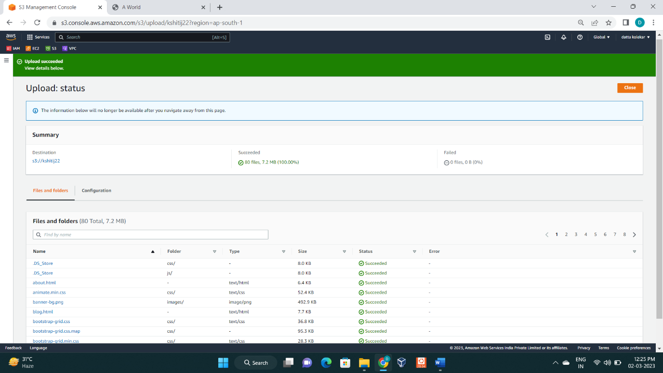

:Now files has been uploaded. Click on **close** button.

Now click on **permission**.

: Go to the edit option

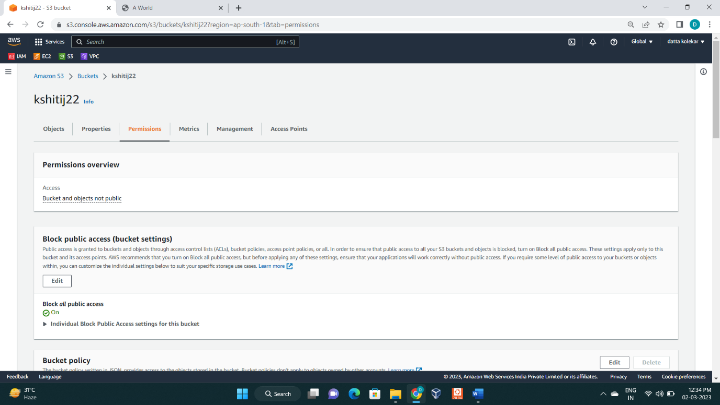

: Go to the option below the **Block public access** option

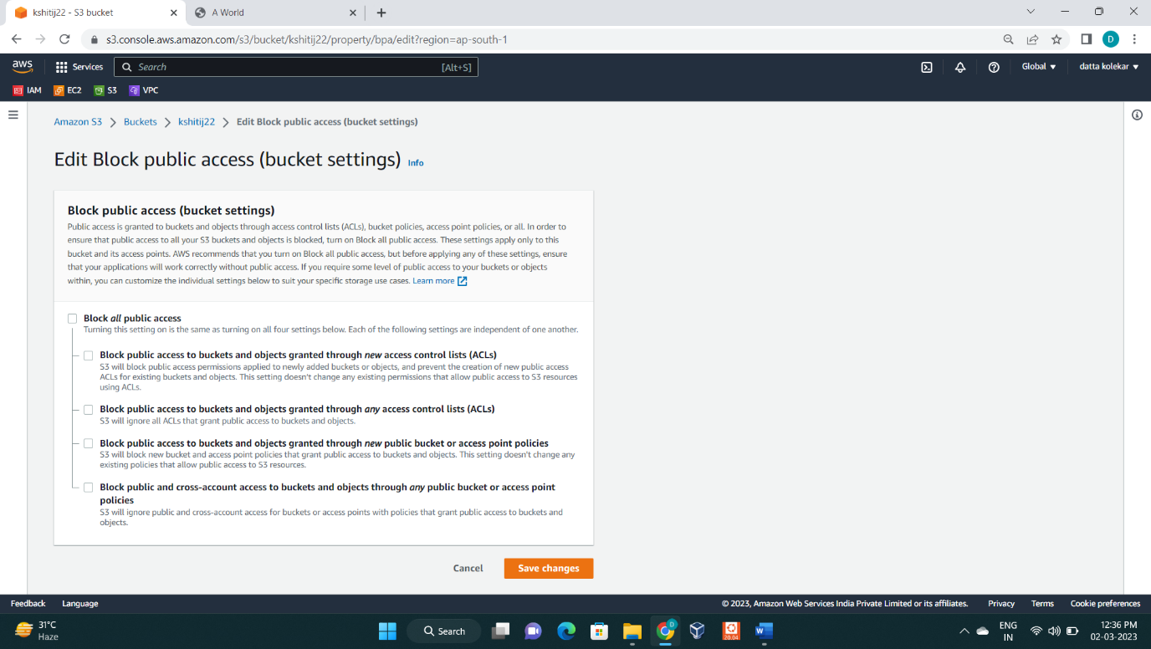

: Unselect option of Block **public access option** and save changes.

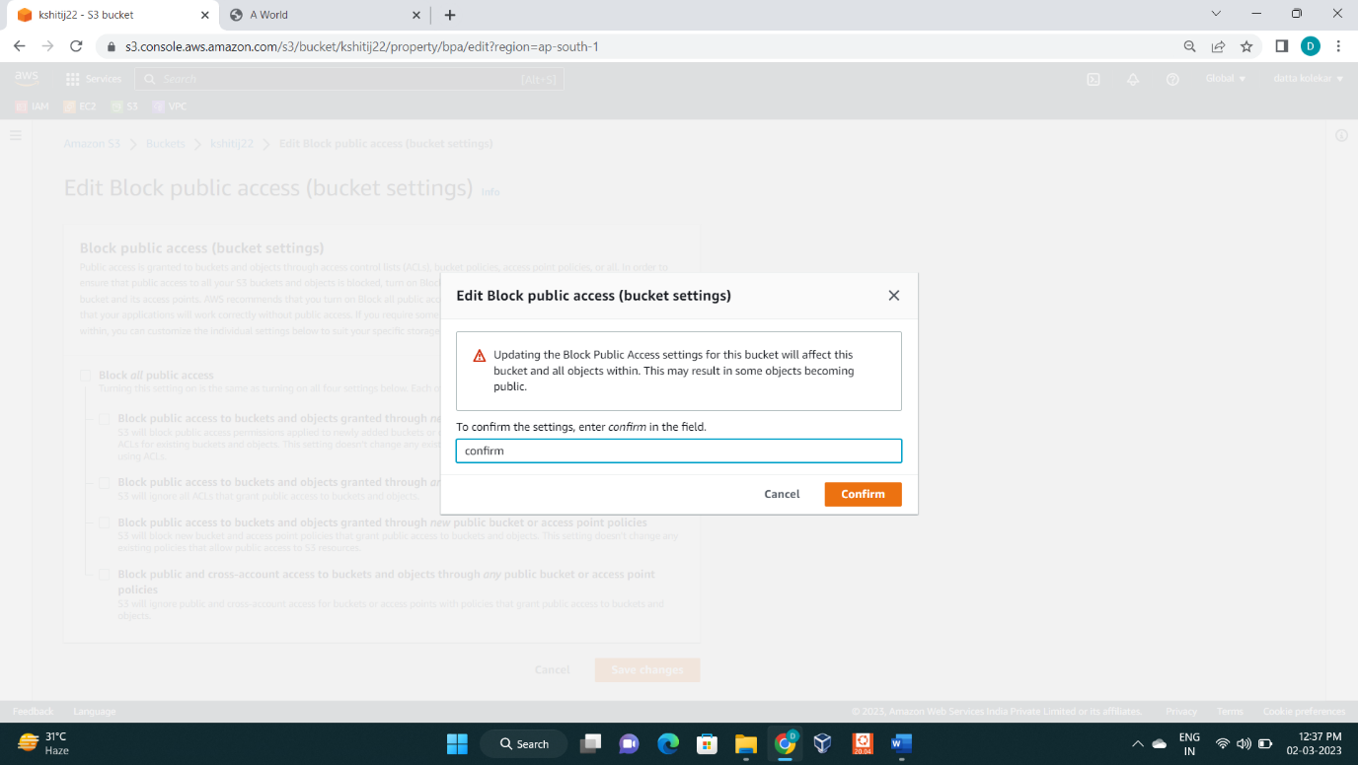

: then type **confirm** and click **confirm** button.

: Scroll down and click on **edit** option on the right side of “object ownership”.

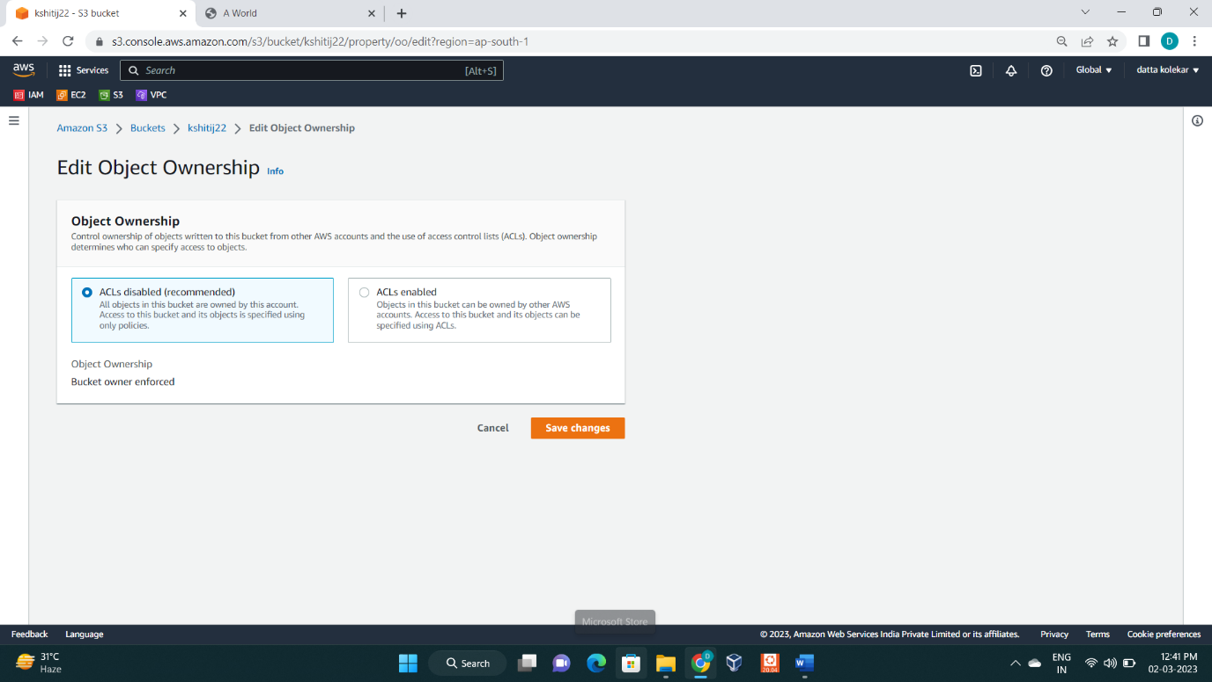

: Click on ACLs enabled

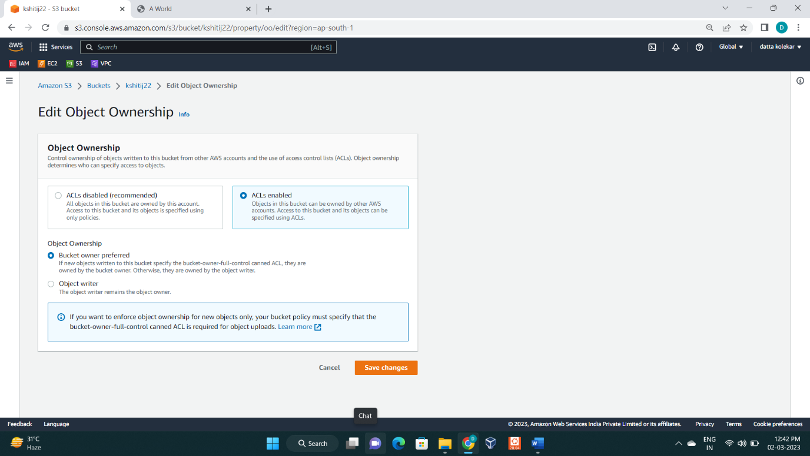

: now click on save changes

: now go to **object** option and select all files and click on action – **make public using ACL**.

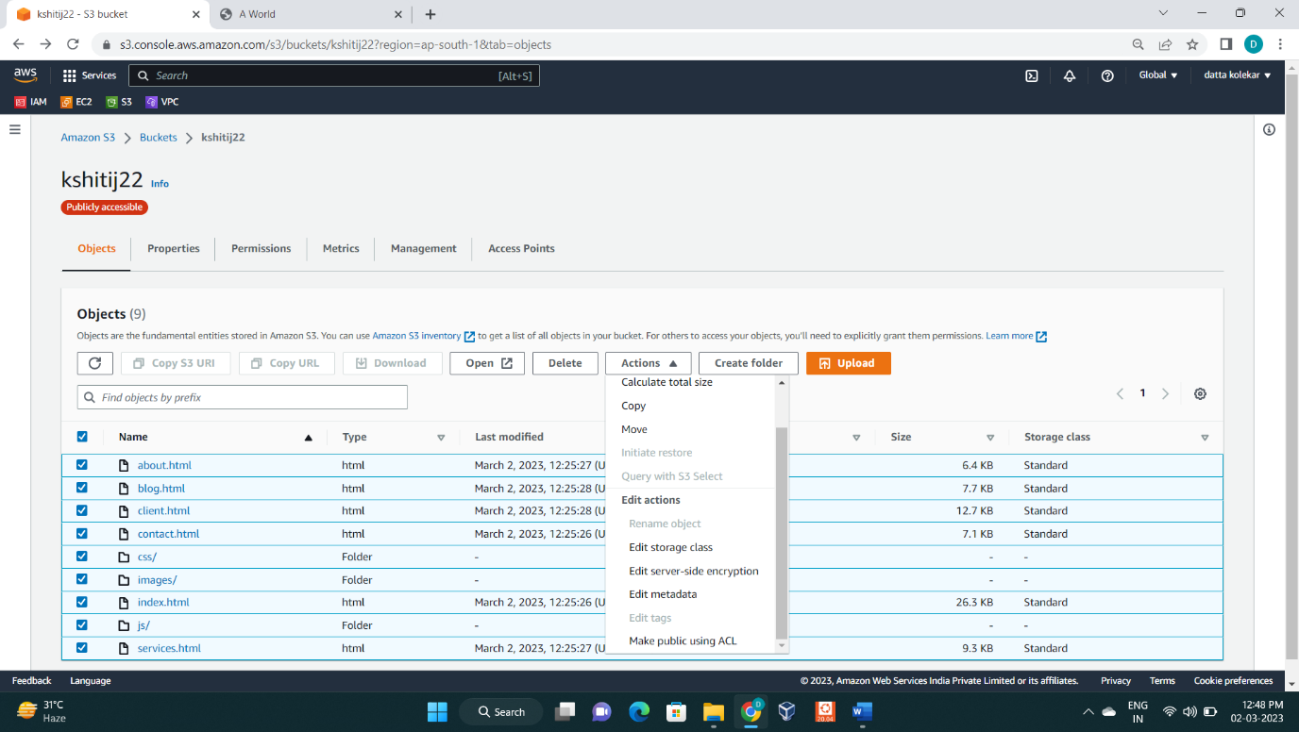

: The following windows will open

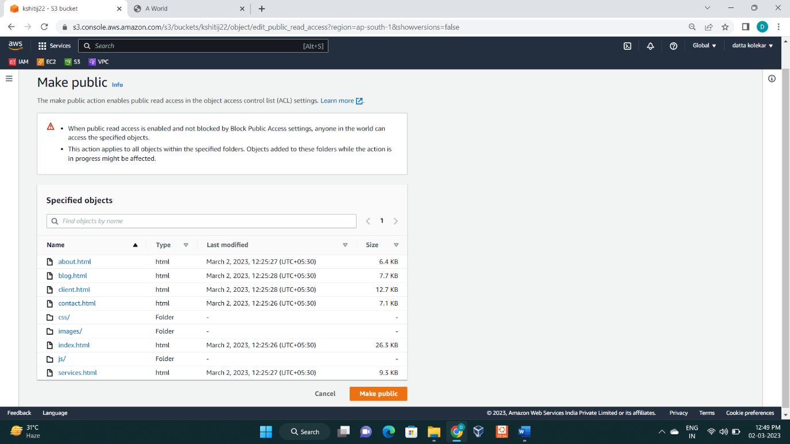

: Then click on **close.** This is show in following window**.**

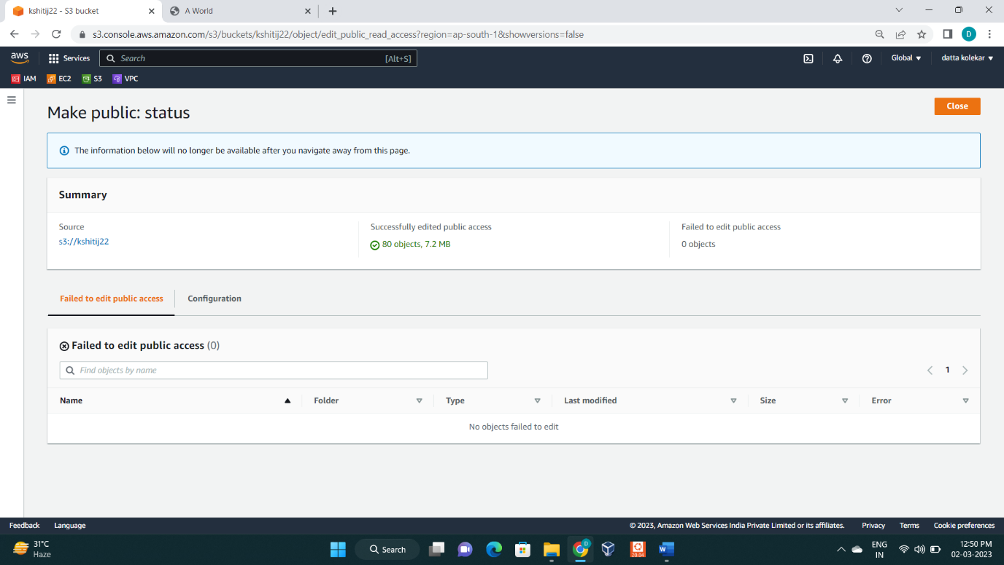

: Now on navigation bar click on properties

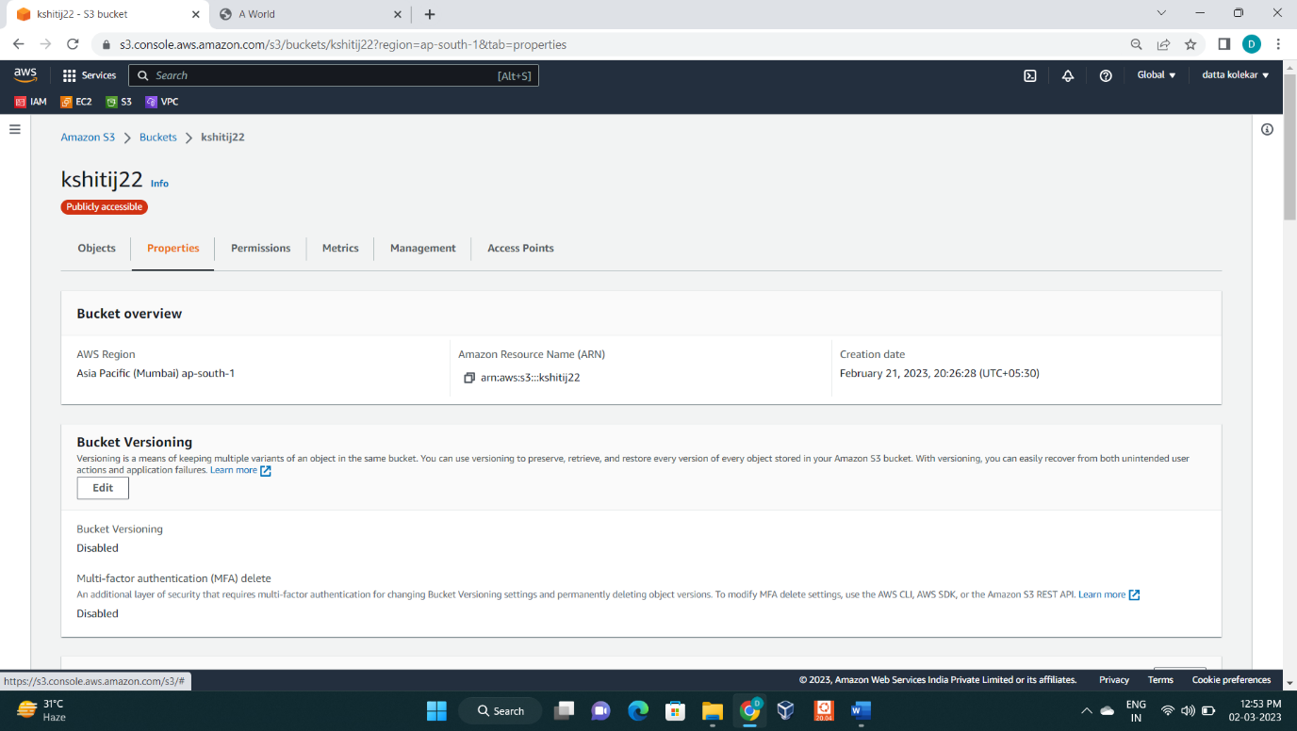

: Scroll down to bottom and edit static website hosting option

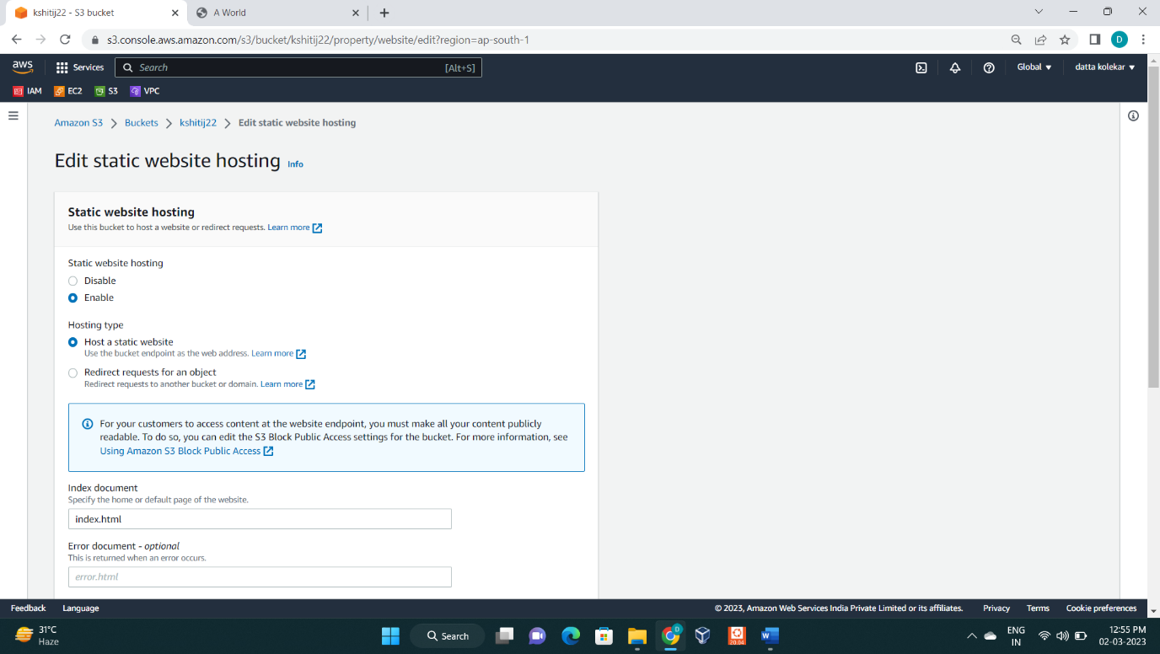

: choose **enable** for static website hosting option.

: choose host type **host a static website** and then type “index.html” in index document option.

: scroll down and click on save changes.

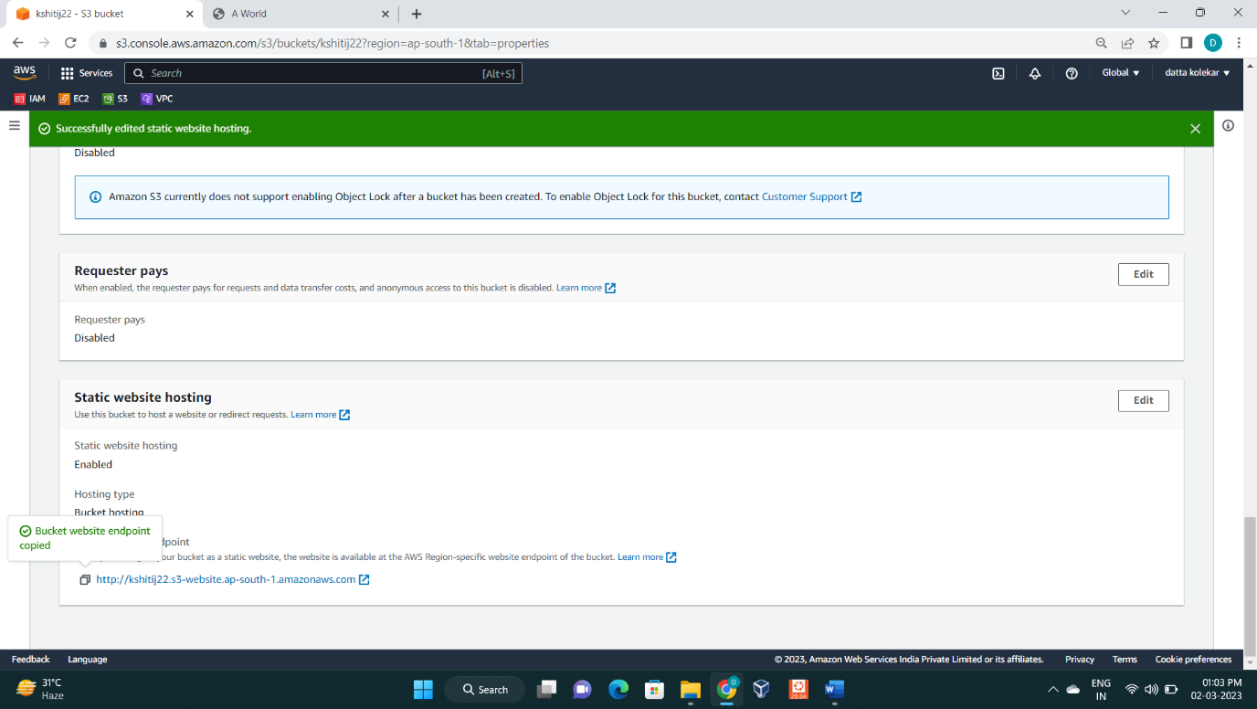

: Copy the link for static website hosting and paste in new tab of chrome.

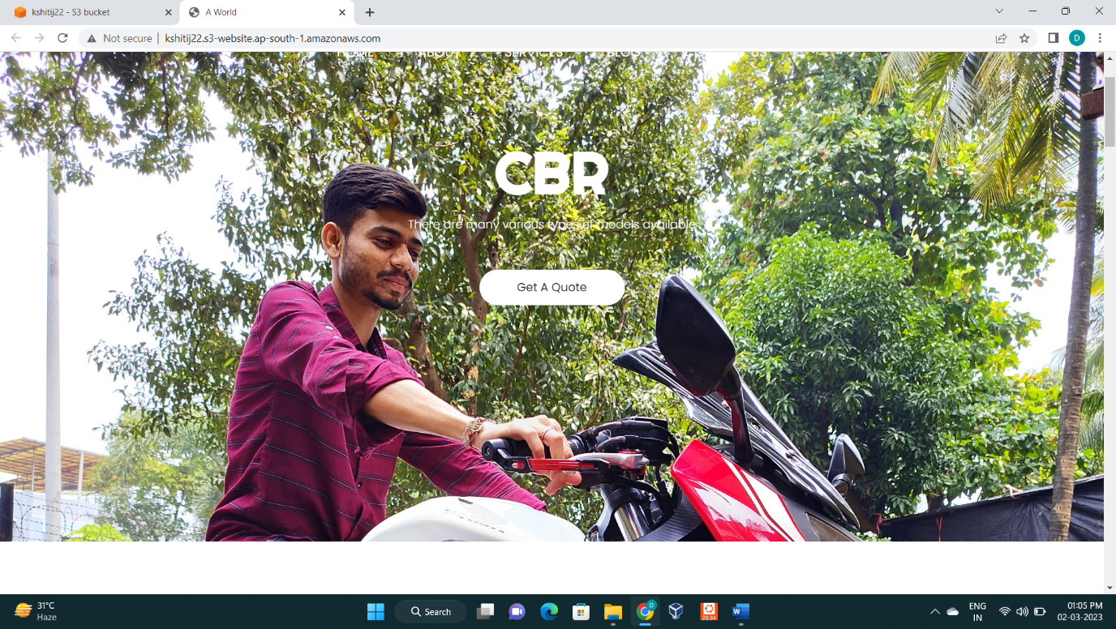

: Now our website has been hosted.

